Introduction to Queues

Azure Queue storage is a service for storing large numbers of messages that can be accessed from anywhere in the world via authenticated calls using HTTP or HTTPS. A single queue message can be up to 64 KB in size, and a queue can contain millions of messages, up to the total capacity limit of a storage account.

Common uses

Common uses of Queue storage include:

* Creating a backlog of work to process asynchronously
* Passing messages from an Azure web role to an Azure worker role

Queue service concepts

The Queue service contains the following components:

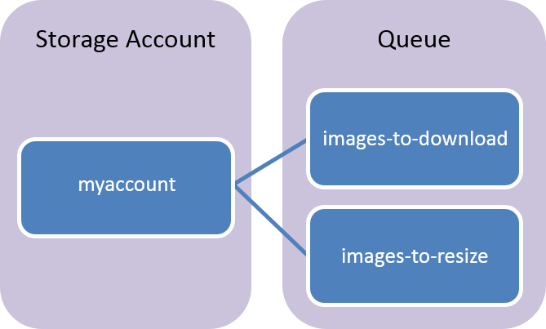

* **URL format:** Queues are addressable using the following URL format:  
  http://<storage account>.queue.core.windows.net/<queue>

The following URL addresses a queue in the diagram:

http://myaccount.queue.core.windows.net/images-to-download

* **Storage account:** All access to Azure Storage is done through a storage account. See [Azure Storage Scalability and Performance Targets](https://docs.microsoft.com/en-in/azure/storage/common/storage-scalability-targets?toc=%2fazure%2fstorage%2fqueues%2ftoc.json) for details about storage account capacity.
* **Queue:** A queue contains a set of messages. All messages must be in a queue. Note that the queue name must be all lowercase. For information on naming queues, see [Naming Queues and Metadata](https://msdn.microsoft.com/library/azure/dd179349.aspx).
* **Message:** A message, in any format, of up to 64 KB. The maximum time that a message can remain in the queue is seven days.

+